Model W5944M-HT RFID Tag Specifications & Data Sheet
The Model W5944M-HT high temperature Tag is capable of surviving the unprecedented temperature of 300°C (572°F), providing identification and tracking capabilities never-before available in rugged or hazardous use-areas. This Tag can be mounted to any metallic surface by bolting, riveting, or welding and endure high pressure environmental conditions.
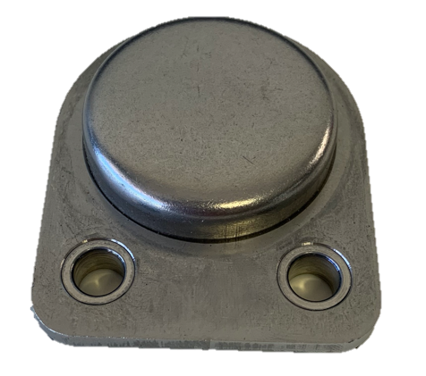
Model Number | Part Number | Description | Read Range (on metal)
W5944M-HT | 807-0016-W5944M-HT | Model W5944M-HT Weldable Metal Mount High Temp 300°C Tag | A99H Antenna – 9’  A55C Antenna – 7’  A64C Antenna – 6’

Mechanical: | Measurements: | 59x44x15mm | 2.3”x1.7”x.59”
 | Material: | Stainless Steel Shell | Ceramic
 | Weight: | 39 grams | 1.4 Ounces
Certifications: | RoHS III | REACH | CE
 | FCC Part 15 | ETSI | Free of BBP, DEHP, DBP, DIBP

Alien Higgs 3: | TID – 64 bits | UID/EPC – 96-480 bits | 512 bits
RF: | Standard: | EPC Class1 Gen2 | ISO 18000-6C
 | Frequency: | 902 – 928 MHz (North America) | 860 – 870 MHz (EU, Japan)
 | Power: | Passive, no Battery | Powered by Reader RF Signal
Chip Options (page 2): | TID – 32 to 208 bits | EPC – 0 to 496 bits | User – 0 to 61,400 bits

Environmental: | Temp, Peak:  Temp, Operating:  Life:  Ingress Protection: | +350°C/+700°F @ 1 hour duration  -85°F to +185°F  40 Year Shelf Life  IP68 | -30°C to +85°C  100k Writes
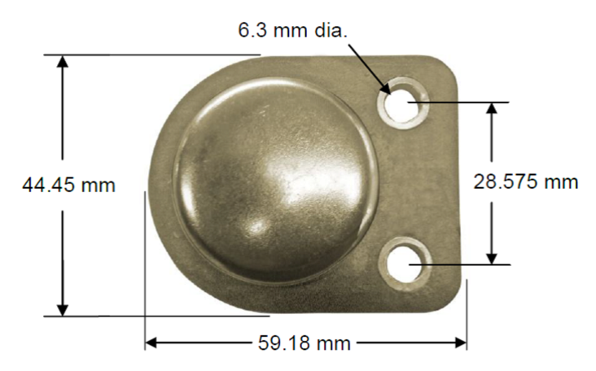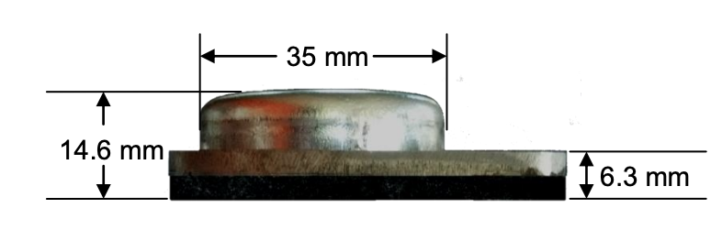
Available UHF Memory Chips:
Alien  Higgs3  Higgs4  HiggsEC  Higgs9 | TID (ROM)  64 bits  64 bits  48 bits  48 bits | UID (EPC)  96 to 480 bits  128 bits  96-128 bits  496 bits | User Memory  512 bits  128 bits  128 bits  688 bits
EM  EM4123  EM4124  EM4126  EM4324  EM4325  EM4423 dual NFC/UHF | TID (ROM)  64 bits  64 bits  32 bits  64 bits  48 bits  96 bits | UID (EPC)  0 bits  96 bits  208 bits  96 bits  352 bits  64-160 bits | User Memory  0 bits  0 bits  0 bits  720 bits  3072 bits
Fujitsu (FRAM)  MB97R88110  MB97R88120/8130  MB97R8050 | TID (ROM)  208 bits  208 bits  176 bits | UID (EPC)  480 bits  480 bits  160 bits | User Memory  61,400 bits  61,400 bits  0 bits
Impinj  M4D  M4E  M4QT  M4i  MX-8k  Monza R6P  Monza R6  Monza R6A  Monza R6B  Monza 5  M730  M750 | TID (ROM)  96 bits  96 bits  96 bits  96 bits  96 bits  96 bits  96 bits  96 bits  96 bits  96 bits  96 bits  96 bits | UID (EPC)  Up to 128 bits  Up to 496 bits  Up to 128 bits  Up to 256 bits  Up to 128 bits  Up to 128 bits  96 bits  96 bits  Up to 128 bits  128 bits  128 bits  96 bits | User Memory  32 bits  128 bits  512 bits  480 bits  8,192 bits  Up to 64 bits  0 bits  0 bits  32 bits  32 bits  0 bits  32 bits
NXP  UCODE 7  UCODE 7m  UCODE 7xm  UCODE 7xm+  UCODE 8  UCODE 8m  UCODE 9  UCODE G2iL & G2iL+  UCODE G2iM  UCODE G2iM+  UCODE G2XM  UCODE G2XL  UCODE HSL | TID (ROM)  48 bits  48 bits  48 bits  48 bits  96 bits  96 bits  96 bits  64 bits  96 bits  96 bits  64 bits  64 bits  64 bits | UID (EPC)  128 bits  128 bits  448 bits  448 bits  128 bits  96 bits  96 bits  128 bits  256 bits  Up to 448 bits  240 bits  240 bits  0 bits | User Memory  0 bits  32 bits  1024 bits  2048 bits  0 bits  32 bits  0 bits  0 bits  512 bits  Up to 640 bits  512 bits  0 bits  1680 bits

